[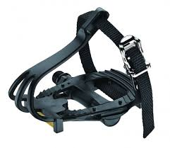](https://www.google.com.eg/url?sa=i&rct=j&q=&esrc=s&source=images&cd=&cad=rja&uact=8&ved=0ahUKEwiugvyAkpTXAhUBmrQKHaRoBvUQjRwIBw&url=https://www.mrcyclingworld.com.au/vp-road-bike-pedals-with-toe-clips-and-straps&psig=AOvVaw3doYOlSq0Hy7rzHXA527u2&ust=1509308368252433)

[](https://www.google.com.eg/url?sa=i&rct=j&q=&esrc=s&source=images&cd=&cad=rja&uact=8&ved=0ahUKEwiugvyAkpTXAhUBmrQKHaRoBvUQjRwIBw&url=https://www.mrcyclingworld.com.au/vp-road-bike-pedals-with-toe-clips-and-straps&psig=AOvVaw3doYOlSq0Hy7rzHXA527u2&ust=1509308368252433)

**Report [1]**

**Technical Writing**

**Dr. Ahmed Emad ElDin**

**Names:**

* Ibrahim Moustafa Ibrahim Fatouh ElShenhapy

**ID:** 4715 **Period:** Monday 3:20-4:50

* Ahmed Mohamed AbdelKader

**ID:** 4649 **Period:** Wednesday 5:00-6:30

* Mahmoud Adel Osman

**ID:** 4647 **Period:** Monday 3:20-4:50

***Bicycles Mechanism***

A bicycle is a device which efficiently converts the power our bodies produce into kinetic energy so that it helps us to go anywhere without much effort as walking or running. [1]

Bicycles work on a rather simple mechanism. There is no major electrical or mechanical principle hidden behind it. It uses two simple techniques which are:

* Applying friction in brakes to stop the bicycle
* The gear mechanism make the bicycle go faster. [1]

Bicycles are used for transport, recreation and exercise or sport. Bicycles provide numerous benefits in comparison with motor vehicles, Cycling offers a reduced consumption of [fossil fuels](https://en.wikipedia.org/wiki/Fossil_fuel), less [air](https://en.wikipedia.org/wiki/Air_pollution) or [noise pollution](https://en.wikipedia.org/wiki/Noise_pollution), and much reduced [traffic congestion](https://en.wikipedia.org/wiki/Traffic_congestion). In fact, as you can see from the chart opposite [***Figure 1***], they're the most efficient transportation machines humans have developed so far. [4]

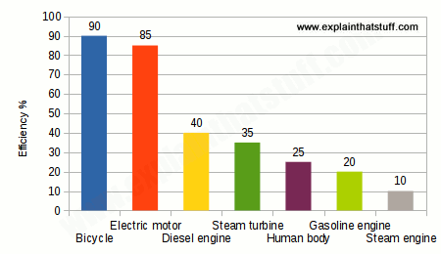

***Figure 1 [1]***

A bicycle is a vehicle with a [tubular](https://www.collinsdictionary.com/dictionary/english/tubular) metal [frame](https://www.collinsdictionary.com/dictionary/english/frame) [mounted](https://www.collinsdictionary.com/dictionary/english/mount) on two [spoked](https://www.collinsdictionary.com/dictionary/english/spoke) [wheels](https://www.collinsdictionary.com/dictionary/english/wheel), one behind the other. The [rider](https://www.collinsdictionary.com/dictionary/english/rider) [sits](https://www.collinsdictionary.com/dictionary/english/sit) on a [saddle](https://www.collinsdictionary.com/dictionary/english/saddle), [propels](https://www.collinsdictionary.com/dictionary/english/propel) the vehicle by means of [pedals](https://www.collinsdictionary.com/dictionary/english/pedal) that [drive](https://www.collinsdictionary.com/dictionary/english/drive) the [rear](https://www.collinsdictionary.com/dictionary/english/rear) wheel through a [chain](https://www.collinsdictionary.com/dictionary/english/chain), and [steers](https://www.collinsdictionary.com/dictionary/english/steer) with handlebars on the [front](https://www.collinsdictionary.com/dictionary/english/front) wheel. [2]

Apart from the frame and the saddle the major parts of the bicycle are: two wheels, a handlebar, pedals, brakes, chain and chain rings. Of course additional equipment like front and back lights, bells, carriages and baskets are added as extra fittings, but a bicycle can very well run without them also. [2]

**Bicycle Wheels**

The wheel of a bicycle is a simple machine mainly consisting of a circular rim with spokes that can rotate on a shaft or axle. They are designed to fit into the frame and hold the tires together. [3]

Bicycle wheels are typically over 50cm (20 inches) in diameter, which is taller than most car wheels. The taller the wheels, the more they multiply your speed when you turn them at the axle. That's why racing bicycles have the tallest wheels. [3]

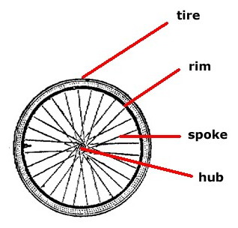 The wheels ultimately support your entire weight. If the wheels were solid, they'd be squashed down as you sat on the seat, and pushing back up to support you. However, the wheels of most bikes are actually formed of a strong hub, a thin rim, and about 24 highly tensioned spokes as shown in [ ***Figure 2*** ]. [3]

The rim is the circular outer part of the wheel, in which the tire rests. The hub is the center of the wheel, where the spokes are attached. The spokes are used to make the wheels strong and lightweight to be easily controlled by the rider using the handlebar. [3]

***Figure 2 [2]***

**Handlebars**

A handlebar is a straight or bent bar(drop) with a handle at each end that is used to steer a bicycle. Drop handlebars allow multiple hand positions: on the top, the hoods (rubber grip above the brake levers) and in the drops as shown in [**Figure3**]. [3]

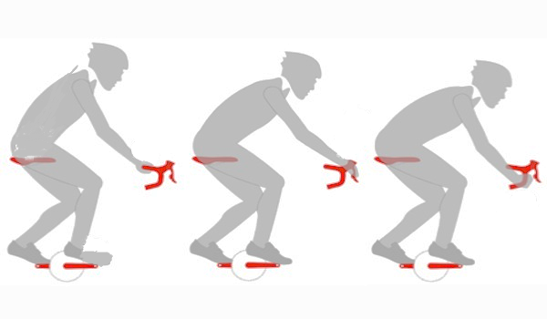

Figure 3 [2]

In any case, it's important that the reach and height of the bar allow you to grasp the brake levers without stretching, and the hooks on a drop bar should offer a position that maximizes the pulling power of your arms and back. [2]

The size of the handlebar, like the stem, should be based on the physical characteristics of the rider. Generally speaking, cross-country riders will want a handlebar one to three inches wider than their shoulders, and those who ride technically demanding trails often prefer their handlebars to be 27 or more inches wide for stability. [4]

The handlebar allows the rider to control the bike and get into different directions. The rider can also stop by holding the brake levers that we will discuss in the next part. [4]

**Bicycle’s Brake System**

In cycling terms: a brake is simply a component or system designed to slow the bike down, and unsurprisingly this slowing down will result in eventually coming to a halt (unless you are coasting down an eternally long hill, or pedaling while braking). [2]

[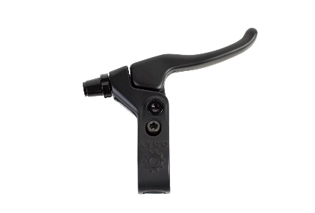](https://www.google.com.eg/url?sa=i&rct=j&q=&esrc=s&source=images&cd=&cad=rja&uact=8&ved=0ahUKEwin5PPGiZTXAhXRYlAKHQohBvAQjRwIBw&url=http://www.odysseybmx.com/catalog/braking/springfield-lever/&psig=AOvVaw2L1AaZuHYEPJl6TgafhggV&ust=1509306079564600) In this section, the fundamental components that make up different braking systems will be broken down and explained. [3]

* **Brake Levers:** A brake lever, shown in [***Figure4***], is located on the handlebar of the bike, and is responsible for allowing the rider to operate the brake remotely. Traditionally, each lever controls a separate brake, so if the bike only has one brake, then it will also only have one lever. [3] ***Figure 4 [2]***

***.***

* [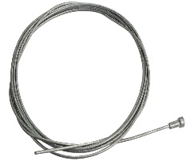](https://www.google.com.eg/url?sa=i&rct=j&q=&esrc=s&source=images&cd=&cad=rja&uact=8&ved=0ahUKEwi33-65ipTXAhVMJlAKHTIHCOYQjRwIBw&url=https://www.evanscycles.com/fwe-campagnolo-inner-brake-cable-EV160635&psig=AOvVaw1AebbRf-G0DPzvwU5nEB71&ust=1509306259420462) **Cables:** The brake cable, shown in [***Figure 5***], is responsible for transferring the energy the rider gives, in the form of pulling the lever, to the brake caliper. [3]

***. Figure 5 [2]***

* [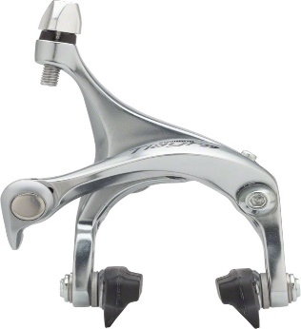](https://www.google.com.eg/url?sa=i&rct=j&q=&esrc=s&source=images&cd=&cad=rja&uact=8&ved=0ahUKEwiA_YSZjJTXAhUCJ1AKHZsNDtEQjRwIBw&url=https://www.modernbike.com/shimano-tiagra-4600-front-brake-caliper-silver&psig=AOvVaw1gBmuup1RjlzcofhOQvCxD&ust=1509306776341071)**Brake Calipers:** Most road bikes operate on a caliper brake design mounted above each wheel. The force applied to the brake lever closes each caliper through tension of a brake cable. The brake caliper is shown in the opposite figure [***Figure6***]. [3]

***. Figure 6 [2]***

* **Rim Brakes:** The rim brake is a braking system that is located on the outer edge of the wheel, and makes use of the wheel rim as a friction surface. [3]
* **Disc Brakes:** Disc brakes make use of a rotor (or disc) that is mounted to the hub of the wheel. This disc is completely fixed to the wheel, so the disc matches the rotational movement of the wheel. A disc brake makes use of a much smaller caliper than a rim brake. [3]

**Pedals:**

The bicycle pedal is the part of a bicycle that the rider pushes with their foot to propel the bicycle. It provides the connection between the cyclist's foot or shoe and the crank. [3]

There are three main types of Pedals: standard platform pedals, toe clips pedals and clipless toes pedals as shown in the opposite figures [***Figure 7/8l9*** ] [2]

[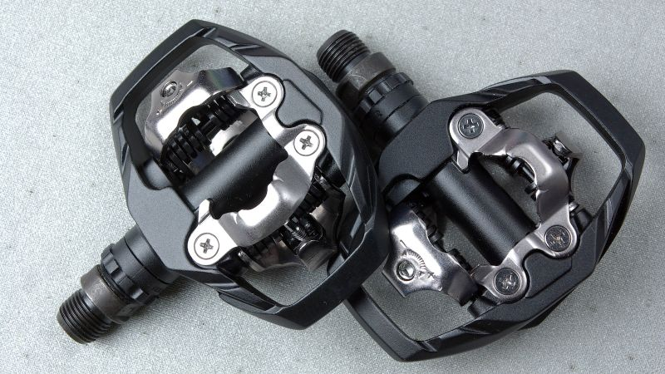](https://www.google.com.eg/url?sa=i&rct=j&q=&esrc=s&source=images&cd=&cad=rja&uact=8&ved=0ahUKEwjZt-HRkpTXAhVGIlAKHQBQCMQQjRwIBw&url=https://gizmodo.com/5990381/why-you-should-switch-to-clipless-pedals&psig=AOvVaw3doYOlSq0Hy7rzHXA527u2&ust=1509308368252433)[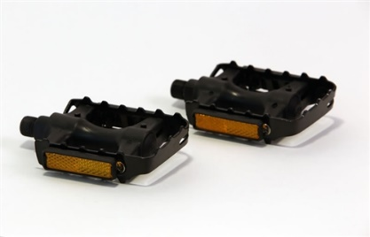](https://www.google.com.eg/url?sa=i&rct=j&q=&esrc=s&source=images&cd=&cad=rja&uact=8&ved=0ahUKEwisg5iJk5TXAhUOZ1AKHV4_AuIQjRwIBw&url=https://shop.terratrike.com/product-p/tt000026.htm&psig=AOvVaw1mTEiputm-cy3r9ARUkFwg&ust=1509308656689429)[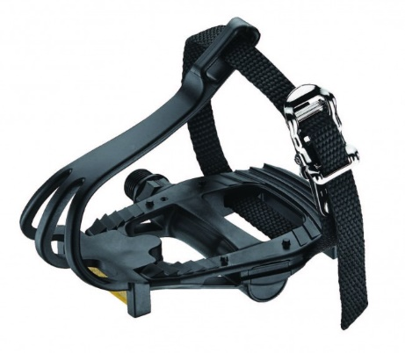](https://www.google.com.eg/url?sa=i&rct=j&q=&esrc=s&source=images&cd=&cad=rja&uact=8&ved=0ahUKEwiugvyAkpTXAhUBmrQKHaRoBvUQjRwIBw&url=https://www.mrcyclingworld.com.au/vp-road-bike-pedals-with-toe-clips-and-straps&psig=AOvVaw3doYOlSq0Hy7rzHXA527u2&ust=1509308368252433)Standard platform pedals Toe clips pedals Clipless pedals

***Figure 7 [4] Figure 8 [4] Figure 9 [4]***

Standard platform pedals are the most common, they are clean, simple and straightforward. Toe clips pedals give you the ability to lift with your foot on the up-stroke as your non-force foot returns to the 12 o'clock position of a stroke. This saves energy by using different muscle groups allowing you to ride farther. [2]

Clipless pedals came after the toe clips, it has been said that clipless pedals can give as much as 30% more power than regular pedals in that you can put serious torque on the return stroke of a pedal. The power from pedaling is transformed to the wheels by using chain which is discussed briefly in the next part. [4]

**Chain and Chain rings:**

A bicycle chain is a roller chain that transfers power from the pedals to the drive-wheel of a bicycle, thus propelling it. Most bicycle chains are made from plain carbon or alloy steel, but some are nickel-plated to prevent rust, or simply for aesthetics. [4]

Chain rings come in different sizes and are circular in shape. Chain rings have spaced teeth used to engage the chain as we can see in [***Figure 10***]. Modern road bikes usually have two or three chain rings. The smaller sizes are use for climbing while the larger are used to generate more speed on flat or downhill sections of road. [4]

[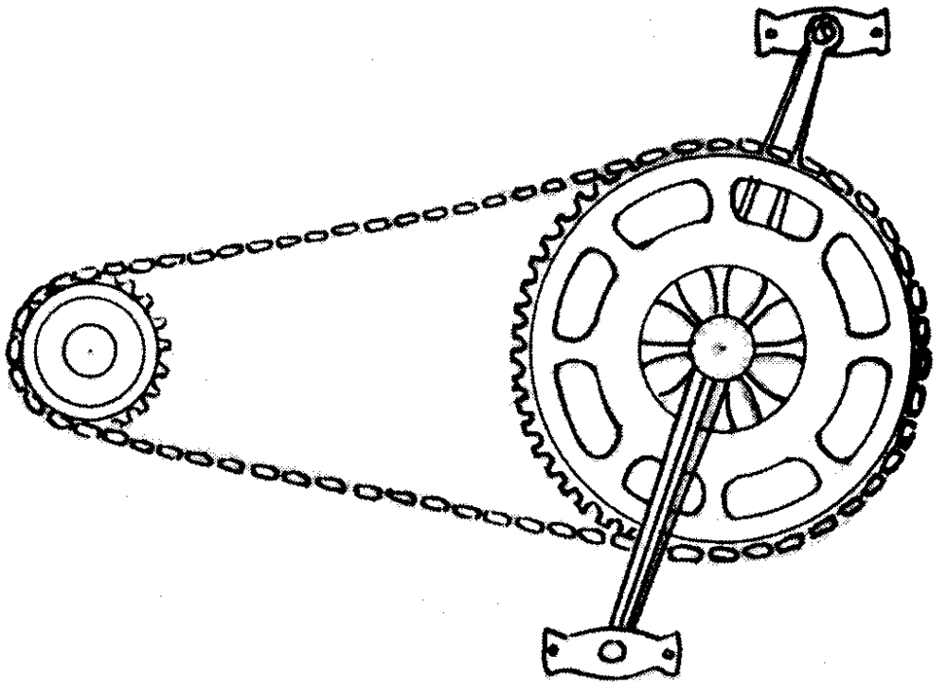](https://www.google.com.eg/url?sa=i&rct=j&q=&esrc=s&source=images&cd=&cad=rja&uact=8&ved=0ahUKEwiE7KbPwZbXAhVLUlAKHabJB9MQjRwIBw&url=https://azaremba01.wordpress.com/2013/08/27/bike-chain/&psig=AOvVaw0Jj835QiFyWH7Vvw7gwH2f&ust=1509389867790006)

***Figure 10 [4]***

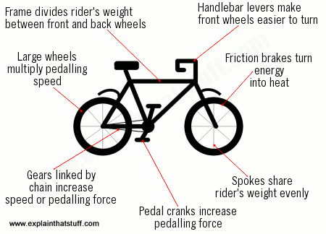 At the end, the bike is basically a mechanical device that has a simple mechanism that depends on the friction force between the wheels and the ground. It can be summarized in the opposite picture [***Figure 11***]. [2]

***Figure 11 [1]***

**References**

***Text:***

1. [***https://adventure.howstuffworks.com/outdoor-activities/biking/bicycle2.html***](https://adventure.howstuffworks.com/outdoor-activities/biking/bicycle2.html)
2. [***https://www.active.com/cycling/articles/the-anatomy-of-a-bicycle/slide-22?page=1***](https://www.active.com/cycling/articles/the-anatomy-of-a-bicycle/slide-22?page=1)
3. [***http://www.trekbikessouthcarolina.com/about/basic-bicycle-anatomy-101-pedals-shoes-pg439.htm***](http://www.trekbikessouthcarolina.com/about/basic-bicycle-anatomy-101-pedals-shoes-pg439.htm)
4. [***http://www.explainthatstuff.com/bicycles.html***](http://www.explainthatstuff.com/bicycles.html)

***Figures:***

1. [***www.explainthatstuff.com***](http://www.explainthatstuff.com)
2. [***http://www.trekbikessouthcarolina.com***](http://www.trekbikessouthcarolina.com)
3. [***https://www.banggood.com/Female-Bicycle-Brake-Lever-Handlebar-MTB-Road-Bike-Multi-style-p-941680.html***](https://www.banggood.com/Female-Bicycle-Brake-Lever-Handlebar-MTB-Road-Bike-Multi-style-p-941680.html)
4. ***http://www.bikepro.com/products/brakes/brakecable/cable_innerwire.html***